Blockchain: Hype or Revolution?

Blockchain is a buzzword that has been loosely flung around to represent anything that means cryptocurrency. In its more formal definition as an immutable ledger, this technology presents ample opportunities to log data in a decentralized system as a result the underlying technology has immense potential across a variety of industries.

>> Focus on 1. investments and 2. deals

In terms of current investments, a survey of 1053 participants globally by Deloitte indicates that Automotive, Life Sciences, Oil & Gas, and Tech/Media/Telecom appear to have invested the most in blockchain technology so far.

Figure 1: Current investment on blockchain technology by industry

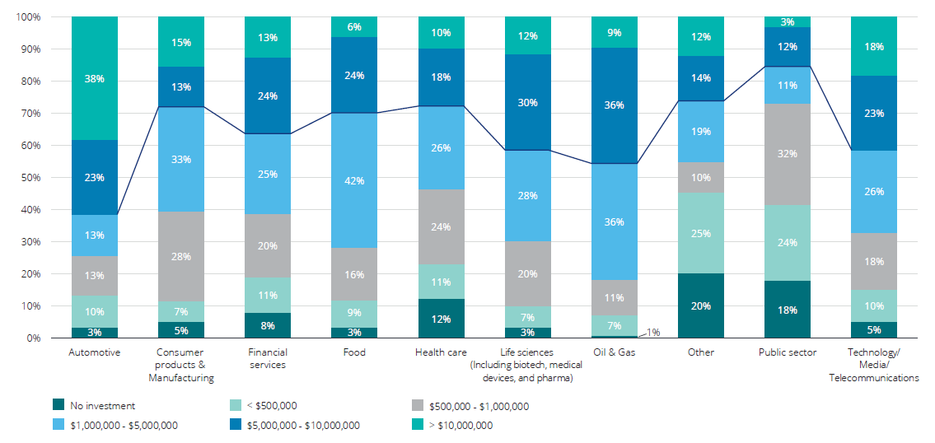

The utilities, agriculture and financial services are among the sectors to be most impacted by the introduction of block chain with most of the advantages arriving in the form of cost savings. But exactly how is this achieved? The financial sector makes a great example.

## Putting a Lid on Costs

Blockchain solutions promise greatly improved cost efficiency in terms of payment processing and automation, reduced labor, and increased security. One of the strongest use cases is in payment authorization and settlement, primarily due to the highly transaction-based nature of the service. According to Centric Digital, blockchain use is expected to be as high as 79% for payment authorization and settlement and 77% for cross-border (time?). Blockchain based Ripple is a real-time gross settlement system, currency exchange and remittance network that can reduce transfer times, and compliance and liquidity costs significantly; customer banks can save 33% on international payments, a 48% drop in payment operations costs, and a 99% decline in Basel III compliance costs, according to Ripple.

Figure 2: Sector wise breakdown of the impact blockchain

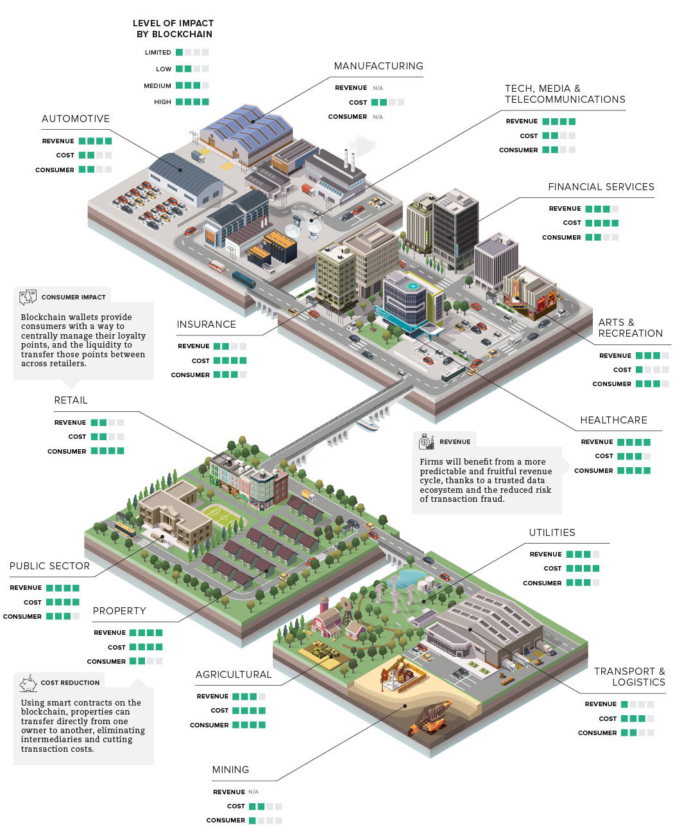

*Source: McKinsey (*[*https://www.weforum.org*](https://www.weforum.org/agenda/2018/12/the-business-value-of-the-blockchain/)*)*

## A Whirlwind of Investment: Who Is Investing?

As blockchain continues to stay at the top of the hype curve, the bulk of the investments continue to occur at the venture capital stage, as seen below, which has quite literally blown out of proportion. However, it is important distinguish the two main types of funding for blockchain startups; ordinary venture capital and Initial Coin Offerings (ICOs). Since 2017, about two thirds of capital invested has been raised. An ICOs is a digital token that represents ownership (similar in principle to stocks) however, ICOs lack any form of regulations and is swathed in controversy.

Figure 3: Rampaging investments in blockchain (excluding ICOs)

## 

*Source:* [*https://techcrunch.com*](https://techcrunch.com/2018/05/20/with-at-least-1-3-billion-invested-globally-in-2018-vc-funding-for-blockchain-blows-past-2017-totals/)

## How Can We Invest in Blockchain While Avoiding Cryptocurrency?

If we are to gain exposure to this promising technology but do not have access to the venture capital space, do we have hope? Well yes, as a result of the hype, blockchain indexes and publicly traded companies have sprung up everywhere. However, we caution in understanding the underlying constituents. We must demarcate from Cryptocurrency based indices (Blockchain index) which are easily distinguishable by their extremely high correlation to cryptocurrency prices such as bitcoin.

Sticking with the viable investments, Innovation Shares KOIN takes a very pragmatic approach and gives its basket a more defined framework by placing stocks one of four custom stakeholder categories in terms of how they relate to the theme; cryptocurrency payment, crypto mining enablers - and the ones we are interested in - Solutions Providers (companies engaged in assisting businesses in the creation and implementation of blockchain applications), and adopters (uses blockchain to increase operational efficiencies and other business processes).

Reality Shares Nasdaq NexGen Economy Blockchain ETFs which provide us with technology exposure to blockchain. However investors should be aware that the constituent stocks are not pure play blockchain players as these are hard, if not impossible to come by for listed securities given the infancy of the field. Nonetheless, the incumbents are heavy advocates and investors in the technology.

Figure 4: NexGen Economy Blockchain ETFs constituents

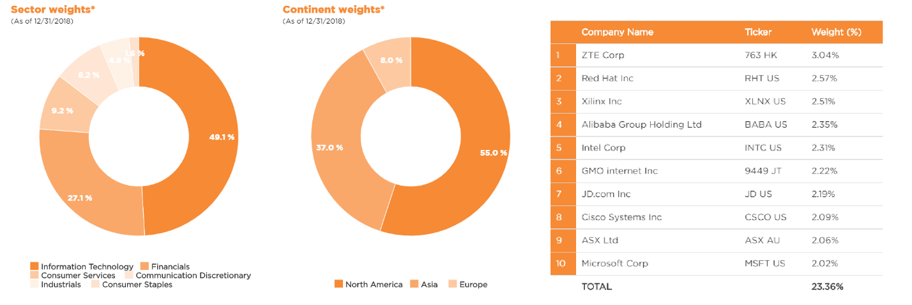*Source:* [*https://www.realityshares.com/app/BLCN*](https://www.realityshares.com/app/BLCN)

# Sources

[*https://fintech.global/blockchain-cryptocurrency-funding-is-on-track-to-surpass-last-years-record-despite-cryptocurrency-market-uncertainty/*](https://fintech.global/blockchain-cryptocurrency-funding-is-on-track-to-surpass-last-years-record-despite-cryptocurrency-market-uncertainty/)

*https://innovationshares.com/koin-summary/*